# LITURGICAL SACRISTAN HANDBOOK

# Initial: October 20, 2023

**Updated: June 20, 2025**

# *INTRODUCTION*

# *Humble Service*

Genuine ministry is about humble service. ‘The holy preparations in which Sacristans are entrusted are the basic framework for the beautiful and sacred objects that are used and carried out before, during, and after the Mass. It’s a serious job that one must undertake with care and wisdom.

# *Attire*

Although much of what the sacristan does is within the confines of the Sacristy, a neat and reverential appearance is in keeping with the minister’s role. The ministers’ attire should not detract from their role.

Our dress and mannerisms should not attract attention to ourselves but instead demonstrate the reverence we show for the presence of God in the Word and Sacrament. Therefore, the following items of clothing are **not** acceptable dress for performing our obligations as a Sacristan:

* 1. **For men:**
     1. Jeans, cargo pants, jogging pants, and other extremely casual slacks
     2. Tee shirts
     3. Bermuda shorts, jogging shorts, or other short pants of any kind
     4. Sneakers, flip-flops, slippers
  2. **For women:**
     1. Tank tops, tee shirts, form-fitting athletic-type tops or spandex slacks and tops
     2. Short skirts (please use your best discretion), jeans, denim skirts, cargo pants, jogging pants and other extremely casual slacks
     3. Bermuda shorts, jogging shorts, or other short pants of any kind
     4. Sneakers, flip-flops, slippers

**Please use your best discretion in keeping with the guidelines set forth by the Diocese.**

# *Training and Ongoing Formation*

Sacristan Training will be conducted as warranted, depending on the need and the retirement of existing Sacristans. There will be recruitment of new Sacristans at various times throughout the year. Please always come to Mass appropriately dressed in case you may need to serve.

# *SCHEDULES AND PROCEDURES*

# *Schedules*

The Sacristan schedules are created for a two-month period and will be available by email around the middle of the previous month. Schedules are created electronically through Ministry Scheduler Pro. Schedules are created using the information each minister has provided relative to their Mass preference(s). Therefore, it is the responsibility of the Sacristans, having been trained, to learn and use Ministry Scheduler Pro for helping the system make the schedule.

There will be **2** Sacristans scheduled for each Mass & **2** Sacristans available to be scheduled per Mass. The number of available Sacristans may change over time based on new ministers and their respective Mass preference(s).

***Substitutes***

If you are unable to/or know beforehand you will not be Sacristan at your assigned Mass, it will be your duty to go into Ministry Scheduler Pro and request a swap out. This will have to be done in a timely manner to provide an opportunity to fill that slot. Please use your best discretion. Every Sacristan will need to have downloaded Ministry Scheduler Pro as this is the primary application for scheduling. The Ministry Scheduler Pro can help you find a substitute when you request a substitute through the electronic scheduler. Your first request should go to the other Sacristan(s) whose preference is the Mass you are asking for a substitute. After you have done that and no one is available, you may reach out to the other Sacristans (outside of your Mass), to see if they can assist.

It is imperative that a Sacristan substitute be found as they are the key minister for their given Mass, ensuring that all vessels are set up properly before the Mass and cleansed after the Mass.

# *Holy Days*

Sacristans will be recruited for Holy Days via email. Please sign up early for these Masses (especially Christmas and Easter).

### *PROCEDURES PRIOR TO THE LITURGY*

# *Sign-in Procedures*

Sacristans should arrive at **least 30 minutes** before Mass. When you arrive at the church, before entering the Sacristy, stop at the MSP kiosk on the wall outside of the Chapel. Choose the appropriate Mass and check in. If you are substituting for someone, simply check in under their name.

# *Opening Prayer*

Pray for the Holy Spirit, using the Sacristan Prayer at the end of this Handbook and on display in the Sacristy. Invite the Holy Spirit to guide you while you serve.

***Vessels Preparation***

***Priest’s Chalice Tray***

1. Check the Clergy Calendar on the bulletin board to see the principal celebrant for your particular Mass.
2. Prepare the Priest’s Chalice in the following order. Please ensure to use the correct Chalice found in the labeled cabinet as some Priests have a daily Chalice and a weekend Chalice.
   1. Chalice
   2. Purificator
   3. Paten (small host is to be placed on the Paten)
   4. Pall
   5. Corporal
   6. Tabernacle Key – please ensure that the correct tabernacle key is placed on top of the Corporal. They are clearly labelled inside of the Priest’s Chalice cabinets.
3. Place the Chalice from step 2 on the dark wood tray which can be found on the shelf of the Sacristy island.
4. Retrieve a cruet from the cabinet and fill it halfway with water. Place the cruet on the tray.
5. **NOTE: DO NOT** place the stopper on the water cruet. It should be left in the cabinet as it is much easier to use at the Altar without the stopper in it.
6. Retrieve a Lavabo bowl from the cabinet and a towel from the drawer. Place the towel inside of the bowl and place it on the tray.
7. Retrieve an Ablution Cup with lid from the cabinet, fill halfway with water. Retrieve a Purificator from the drawer. Place the cup and Purificator on the tray.
8. Retrieve the cruet with the wine from the refrigerator. Ensure that the cruet is filled halfway with wine. Place cruet to the side as it will be taken out separately to the table in front of the Baptismal Font.
9. Retrieve a large Ciboria (with lid and handle) from the cabinet. Inside the Ciboria, fill with unconsecrated hosts (half-filled).
10. Place the Large Ciboria and wine cruet next to each other on the counter.
11. Please see the Appendix of this document for a picture of the Chalice Tray.

***Ciboria Trays***

1. Retrieve 8 small Ciboria from the cabinet and place them in the individual slots on the Ciborium tray which can be found on the shelf of the Sacristy island.
2. Prior to placing hosts into the Ciboria, you should have checked the Tabernacle to see how many consecrated hosts are there. If in doubt, ask the Priest or Deacon to check the Tabernacle for you and report back to you.
3. Stop by the table behind the choir wall and see what the Mass counts have been for your Mass. This will help to give a better idea of what you might expect for attendance so that you can estimate accordingly.
4. Additionally, speak with the Lead Usher (or at the very least, an Usher) and advise they should come and find you should there appear to be a larger crowd than anticipated so that you can adjust the host count, as needed, before the Offertory.
5. Based on the current estimate count per Mass (see sheet on wall of Sacristy and Appendix of this handbook), fill the Ciboria with the appropriate number of hosts. **Please note that if necessary, you may leave some of the Ciboria empty when placing them in the trays. This will allow the Deacon to only need to fill up a few Ciboria versus having to fill all 8 while at the altar.**
6. Each new bag of hosts contains 250 hosts. The picture on the Sacristy wall of the various Ciboria that could be used for Mass will help give you an idea of how many hosts each holds as you look to distribute among the eight (8) Ciboria.
7. Once the Ciboria are filled, place one (1) Purificator on one of the trays.
8. Please see the Appendix of this document for a picture of the Ciboria Trays.

***Chalice Tray***

1. Retrieve 4 Chalices from the cabinet and place them in the individual slots on the Chalice tray which can be found on the shelf of the Sacristy island.
2. Fill each chalice halfway with wine using the measuring cup and place four (4) Purificators on the tray.
3. Please see the Appendix of this document for a picture of the Chalice Tray.

After all of four (4) trays have been prepared, they are to be brought to the main church.

The two (2) Ciboria trays, the one (1) Priest’s Chalice tray and the one (1) Chalice tray are to be taken and placed on the Credence Table ***BEHIND*** the choir loft.

The large Ciboria and wine cruet are to be placed on the table in front of the Baptismal font.

Ask the Altar Servers who are present to help you bring out the necessary trays. If no Servers are present, ask an EMHC or potentially the Deacon, to assist you. It may be prudent that you (Sacristan) take out the tray of Chalices with the wine.

Please see the Appendix of this document for pictures of the setup.

***Additional Liturgical Preparation***

1. It is the Sacristan’s responsibility to ensure that enough hosts have been put out for Mass so once Mass begins, around the time of the Gospel, they should scan the attendees to see if more hosts should be added.
2. If it is determined that more hosts are needed, retrieve the large Ciboria from the Baptismal Font table and go back to the Sacristy.
3. Add the appropriate number of hosts and return to the Baptismal Font table.
4. Ensure that the Readers and Extraordinary Ministers of Holy Communion (EMHC) positions have been filled. If there is a need to fill a position(s), please ask those you know within the congregation if they can assist (if they are in appropriate attire).
   1. You may also enlist the assistance of the Deacon of the Mass to help find substitutes, as needed.

***Vessels Clean Up***

The Sacristan is responsible for taking the sacred vessels from the Credence Table and carrying them to the Sacristy where they will clean the vessels. They can enlist the assistance of Altar Servers, an EMHC or others to help bring the trays back.

The vessels are purified by the Priest, Deacon, and/or acolyte on the altar after the Blessed Sacrament has been distributed to the community. The exception to this are the Chalices used by the EMHCs. They are not purified at the altar rather, the EMHCs simply return them to the Credence Table. Per our clergy, ***they would also like all vessels to be purified in the Sacrarium once they are brought back to the Sacristy* (See Purification of Sacred Vessels)*.*** There is still the possibility of fragments within the Ciboria and Chalice, even after purification at the altar. Our clergy would like to error on the side of caution and purify again, over the Sacrarium.

Once purified, washing of the vessels can continue per the guidelines below.

***Our clergy has asked that the clean-up team (Sacristan) wait until most of the congregation has left the church after Mass before taking the trays back to the Sacristy. In this way, they can eliminate the need to “push through the crowd” directly after Mass. This should still leave ample time to clean the vessels and prepare them for the next Mass.***

***Ciboria, Priest Chalice and EMHC Chalices***

1. Rinse the Ciboria, Ciboria covers, and the EMHC Chalices without submerging them in the Sacrarium. Dry them thoroughly with a soft, colored microfiber towel and place them back in the cabinets on the appropriate shelf. **Do not rinse the soapy suds in the Sacrarium.**
2. For the Celebrant’s Chalice, only the outside of the Chalice is to be rinsed with water. He will have purified the inside on the altar. Never clean the inside of the Chalice with soap or any other chemical, only the outside is to be rinsed with water**.**
3. Please **DO NOT** submerge the vessels in water. Water seeps into the bottom of the vessels, and they will become corroded.
4. Place all used purificators into the basket to the right of the sink area; the Linen Sacristans will purify and clean the items left in this basket.

***Lavabo Bowl, Ablution Cup, and Wine Cruet***

1. Place the Lavabo towel in the laundry bin.
2. Rinse Lavabo Bowl with water. Dry it with soft towels and place the Lavabo Bowl back in the cabinet.
3. Pour the contents of the Ablution Cup down the Sacrarium.
4. Rinse the Ablution Cup in the Sacrarium. Dry with the soft, colored microfiber towels and leave it on the counter along with the closed lids.
5. Ensure that the wine cruet is filled halfway and then place in the refrigerator for the next Mass.

Wipe down (dry) the Sacrarium, sink, faucet, and sink covers with paper towels to maximize the use of the soft microfiber towels. The microfiber towels should continue to be used to dry sacred vessels and when dirty, placed in the laundry bin. Otherwise, hang them over the rack at the end of the Sacristy island.

***Corporal***

1. In the past, the Corporal would remain on the altar from one Mass to the next and would not be removed until done so by the Linen Sacristan on a weekly basis. Going forward, the Corporal will now be removed at each Mass.
2. After the completion of Holy Communion, the Corporal will be folded up by the Priest (at the altar) and placed on top of the Pall which sits on top of the Priest’s Chalice. The altar, as is done today, is then cleared of all trays and vessels.
3. Once back in the Sacristy, the Corporal is to be unfolded over the Sacrarium and the fragments allowed to fall into the Sacrarium. Once that is completed, if the Corporal is clean and does not appear to have dirt or spots on it, the Corporal can be folded as it was when brought into the Sacristy and used again for the next Mass.
4. If the Corporal is dirty and a new one is needed, simply add the Corporal to the bin with the used Purificators and retrieve a new Corporal from the drawer. **Be sure to choose the Corporal for the main Church and not one that is labeled for the Holy Family Chapel.**
5. Whether it is a new Corporal or a previously used one, it should be placed on top of the Pall on the Priest’s chalice in preparation for the next Mass. It should not be taken back into the church and placed back on the altar. The Deacon (or Priest) will do so when he prepares the altar during the Offertory. Please see the Appendix for pictures on how the Corporal should be folded.

**NOTE:** *After the 730 am Mass, as there may be limited time before the next Mass begins, please proceed to help set up the sacred vessels on the trays before you depart. There is no need to place hosts in the Ciboria but at the very least, please ensure that all vessels and bowls are on the appropriate trays.* *This will help expedite the set-up process for the next Mass.*

***Purification of Sacred Vessels (in the Sacristy)***

Please follow the instructions below.

Although it occurs after the dismissal, the Purification Rite is still part of the liturgy. Moreover, the vessels contain the Body and Blood of Christ and should therefore be handled with reverence.

1. Consume all visible hosts of the Eucharistic bread and consume any visible Precious Blood.
2. Rinse the Ciboria and Chalices in the Sacrarium (the sink on the left with the lid).
3. Once this task is completed, wash the vessels as outlined in the section of this document designated as “Vessels Clean Up.”

**A Sacristan’s Prayer**

**Lord, God of Hosts**

**Your Son, Jesus, sent His disciples ahead of Him,**

**to prepare all things for the Passover Meal,**

**For the event of His Last Supper.**

**Like them I have been given the honor of preparing the special place**

**Where the memory of that Sacred Meal will be relived.**

**May my concerns**

**For the prayerfulness of these surroundings,**

**For the order and neatness of this sacred space,**

**For the holy vessels and all that is needed,**

**Be my sincere preparation for this time of worship.**

**May I not approach this holy service as a mere task,**

**But see in it the opportunity to serve you, Lord,**

**As well as the community of worshippers**

**And the other ministers of the Altar.**

**May the work I perform,**

**While unseen by many,**

**Be a source of visible glory and honor to you.**

**I ask this through our Lord Jesus Christ,**

**Who lives with You and the Holy Spirit forever and ever. Amen.**

**Credence Table Setup for Weekend Masses**

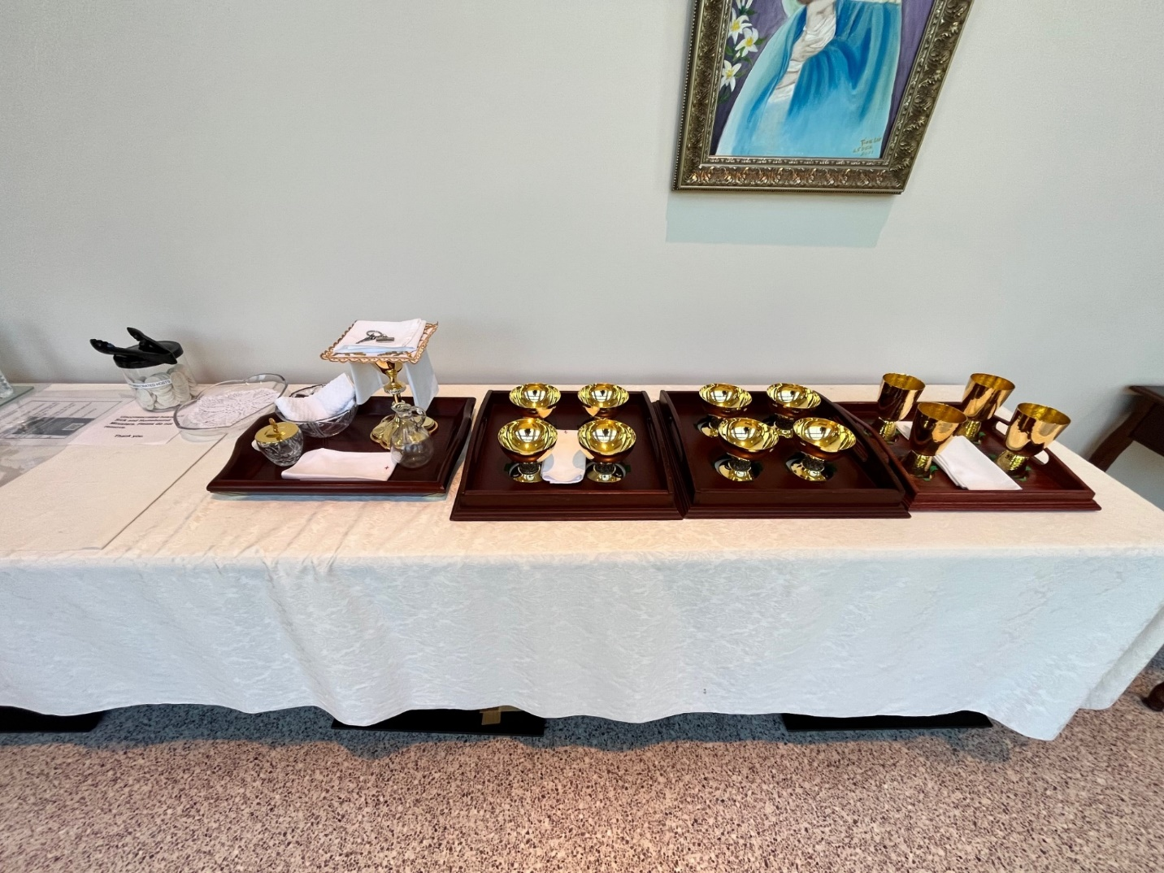

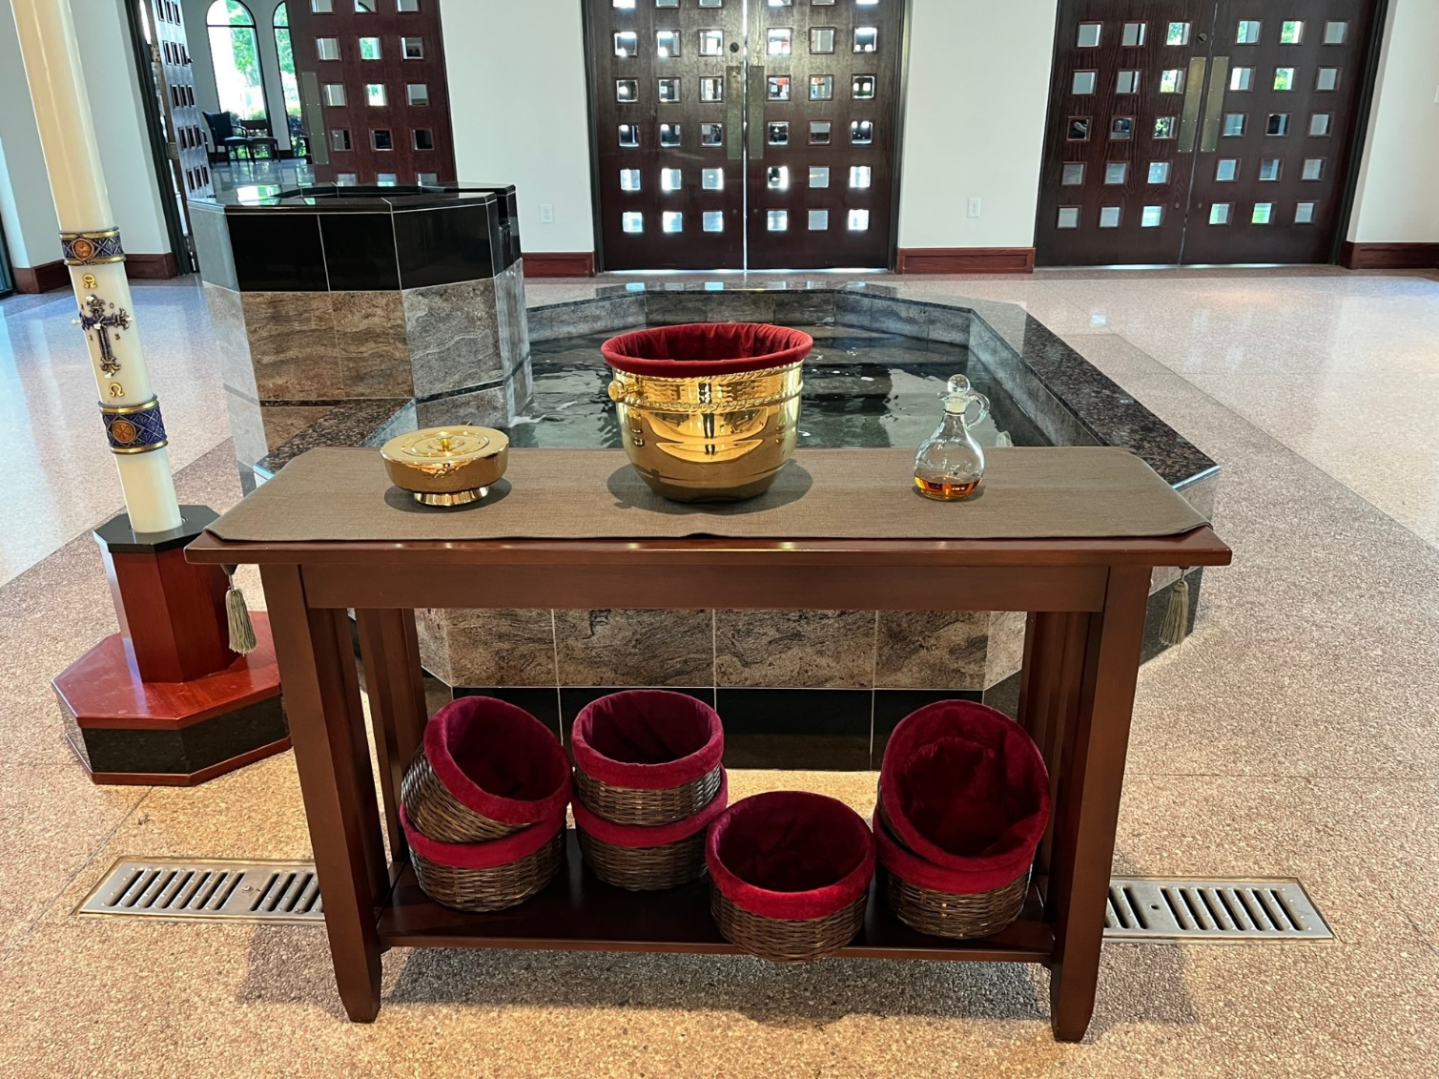



***Folding the Corporal***

The Corporal should begin face up.

The bottom half is folded upward.

The top half is folded downward over the bottom half.

The right side is folded over (to the left).

The left side is folded over to cover the right side which was just folded. This is the final product, and it should be placed on top of the Pall just as you see it.

Once it is placed on the Altar by the Deacon (or Priest), the Cross is placed nearest the Celebrant and unfolded in the opposite direction it was folded, being careful never to turn it over or shake it.

