Lesson 21 Feb. 21 Acts 19:21–22 and 20 Macedonia and Greece
In our last lesson, Paul travels to Ephesus, leaving Apollos in Corinth. He finds that many who were baptized there had received a baptism of repentance, but had not received the Holy Spirit. Paul laid hands on these believers and they received the Holy Spirit. They began speaking in tongues and they prophesied. Paul spent two years in Ephesus and the Lord worked mighty deeds through Paul. And so, it was said that even wash cloths or aprons that had touched Paul’s skin would heal those who came in contact with them. Jewish exorcists tried to expel demons in the name of Jesus, but those evil spirits denied knowing these men and proclaimed that they did, however, know Jesus and Paul. Believers who had once dabbled in the occult and magic burned their books and changed their ways. Also, in Ephesus, Silversmiths who made a living by creating idols and images of the goddess Artemis rioted in protest to Paul’s teaching about One God. The town clerk was able to calm the crowd and dismissed them. He insisted that any actions against Paul and the Christians had to be done in court by a lawful assembly and not by a riotous crowd.

- When did you feel closest to God this week? Was there a particular verse or message in this week’s lesson from Acts 20 that you found inspiring?

- What were Paul’s long-term travel plans? See Acts 19:21-22.

Acts 19:21-22²¹ When this was concluded, Paul made up his mind to travel through Macedonia and Achaia, and then to go on to Jerusalem, saying, “After I have been there, I must visit Rome also.” ²² Then he sent to Macedonia two of his assistants, Timothy and Erastus, while he himself stayed for a while in the province of Asia.

- Read Acts 20:1-6. There is no mention of Luke in these verses. Why do we think that Luke was also present during this part of the Third Missionary Journey?
Acts 20:1-6¹ When the disturbance was over, Paul had the disciples summoned and, after encouraging them, he bade them farewell and set out on his journey to Macedonia. ² As he traveled throughout those regions, he provided many words of encouragement for them. Then he arrived in Greece, ³ where he stayed for three months. But when a plot was made against him by the Jews as he was about to set sail for Syria, he decided to return by way of Macedonia.
⁴ Sopater, the son of Pyrrhus, from Beroea, accompanied him, as did Aristarchus and Secundus from Thessalonica, Gaius from Derbe, Timothy, and Tychicus and Trophimus from Asia ⁵ who went on ahead and waited for us at Troas. ⁶ We sailed from Philippi after the feast of Unleavened Bread, and rejoined them five days later in Troas, where we spent a week.
- Where is Troas? See map below. Reflection. Why do you suppose there are so many named disciples with Paul at this time? See Acts 20:4-6 above.
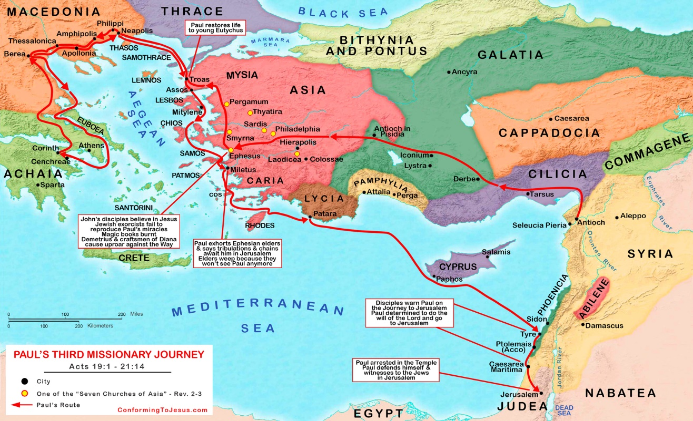

- Read Acts 20:7-12. How much time do you suppose Paul spent speaking with those gathered in this account? Why so much time?
Acts 20:7-12⁷ On the first day of the week when we gathered to break bread, Paul spoke to them because he was going to leave on the next day, and he kept on speaking until midnight. ⁸ There were many lamps in the upstairs room where we were gathered, ⁹ and a young man named Eutychus who was sitting on the window sill was sinking into a deep sleep as Paul talked on and on. Once overcome by sleep, he fell down from the third story and when he was picked up, he was dead. ¹⁰ Paul went down, threw himself upon him, and said as he embraced him, “Don’t be alarmed; there is life in him.” ¹¹ Then he returned upstairs, broke the bread, and ate; after a long conversation that lasted until daybreak, he departed. ¹² And they took the boy away alive and were immeasurably comforted.

- What day is the “first day of the week”? What is significant about this day for Christians? See footnotes for comments on this.

- What happened to Eutychus?

- Compare Acts 20:7-12 above with 1 Kings 17:17-24 and 2 Kings 4:32-35. How are these situations similar? How are Paul’s actions much like those of the prophets Elijah and Elisha?
1 Kings 17:17-24 Sometime later the son of the woman, the owner of the house, fell sick, and his sickness grew more severe until he stopped breathing. ¹⁸ So she said to Elijah, “Why have you done this to me, man of God? Have you come to me to call attention to my guilt and to kill my son?” ¹⁹ Elijah said to her, “Give me your son.” Taking him from her lap, he carried him to the upper room where he was staying, and laid him on his own bed. ²⁰ He called out to the Lord: “Lord, my God, will you afflict even the widow with whom I am staying by killing her son?” ²¹ Then he stretched himself out upon the child three times and he called out to the Lord: “Lord, my God, let the life breath return to the body of this child.” ²² The Lord heard the prayer of Elijah; the life breath returned to the child’s body and he lived. ²³ Taking the child, Elijah carried him down into the house from the upper room and gave him to his mother. Elijah said, “See! Your son is alive.” ²⁴ The woman said to Elijah, “Now indeed I know that you are a man of God, and it is truly the word of the Lord that you speak.”

2 Kings 4:32-35 ³² When Elisha reached the house, he found the boy dead, lying on the bed. ³³ He went in, closed the door on them both, and prayed to the Lord. ³⁴ Then he lay upon the child on the bed, placing his mouth upon the child’s mouth, his eyes upon the eyes, and his hands upon the hands. As Elisha stretched himself over the child, the boy’s flesh became warm. ³⁵ He arose, paced up and down the room, and then once more stretched himself over him, and the boy sneezed seven times and opened his eyes.

- Why is Paul in a hurry to get to Jerusalem? Read Acts 20:13-16.
Read Acts 20:13-16¹³ We went ahead to the ship and set sail for Assos where we were to take Paul on board, as he had arranged, since he was going overland. ¹⁴ When he met us in Assos, we took him aboard and went on to Mitylene. ¹⁵ We sailed away from there on the next day and reached a point off Chios, and a day later we reached Samos, and on the following day we arrived at Miletus. ^{16 [e]}Paul had decided to sail past Ephesus in order not to lose time in the province of Asia, for he was hurrying to be in Jerusalem, if at all possible, for the day of Pentecost.

- Paul gathers the elders or presbyters together in Miletus. Read Acts 20:22-25. What is Paul saying here?
Acts 20:22-25 ²² But now, compelled by the Spirit, I am going to Jerusalem. What will happen to me there I do not know, ²³ except that in one city after another the holy Spirit has been warning me that imprisonment and hardships await me. ²⁴ Yet I consider life of no importance to me, if only I may finish my course and the ministry that I received from the Lord Jesus, to bear witness to the gospel of God’s grace. ²⁵ “But now I know that none of you to whom I preached the kingdom during my travels will ever see my face again.
- What advice or message does Paul leave with the elders? See Acts 20:28-38.
Acts 20:28-38²⁸ Keep watch over yourselves and over the whole flock of which the holy Spirit has appointed you overseers,^{[f]} in which you tend the church of God that he acquired with his own blood. ²⁹ I know that after my departure savage wolves will come among you, and they will not spare the flock. ³⁰ And from your own group, men will come forward perverting the truth to draw the disciples away after them. ³¹ So be vigilant and remember that for three years, night and day, I unceasingly admonished each of you with tears. ³² And now I commend you to God and to that gracious word of his that can build you up and give you the inheritance among all who are consecrated. ³³ I have never wanted anyone’s silver or gold or clothing. ³⁴ You know well that these very hands have served my needs and my companions. ³⁵ In every way I have shown you that by hard work of that sort we must help the weak, and keep in mind the words of the Lord Jesus who himself said, ‘It is more blessed to give than to receive.’” ³⁶ When he had finished speaking he knelt down and prayed with them all. ³⁷ They were all weeping loudly as they threw their arms around Paul and kissed him, ³⁸ for they were deeply distressed that he had said that they would never see his face again. Then they escorted him to the ship.

