Jan. 28 Lesson 18 Acts 17: Thessalonica, Beroea, Athens
In our last lesson, Paul and Barnabas separated over a minor disagreement. Barnabas and Mark went on the Cyprus, while Paul and Silas traveled through Syria and Cilicia. Paul had Timothy circumcised so he would be received favorably by the Jews. Paul had a vision about a call for help in Macedonia and Paul immediately went there to proclaim the Good News. Lydia, a woman and merchant of purple cloth becomes a believer. Paul and Silas encounter a fortune-teller who was possessed by a demon, the devil or a python spirit, who loudly mocks Paul and Silas. Paul exercises the spirit and winds up in prison. The owners of the possessed slave girl who told fortunes, lost their livelihood when the demon was exorcized. An earthquake freed Paul and his companions, but they do not leave their cell, much to the surprise of the jailer. When a release was arranged for Paul and Silas in secret, Paul claims privileges of a Roman citizen. The beatings of a citizen without a trial was a violation of Roman law, so Paul requested a personal release and perhaps an apology from the magistrate. He does receive this, but is also asked to leave the city. After a quick visit to the home of Lydia they leave.

- When did you feel closest to God this week? Was there a particular verse or message in this week’s lesson from Acts 17 that you found inspiring?

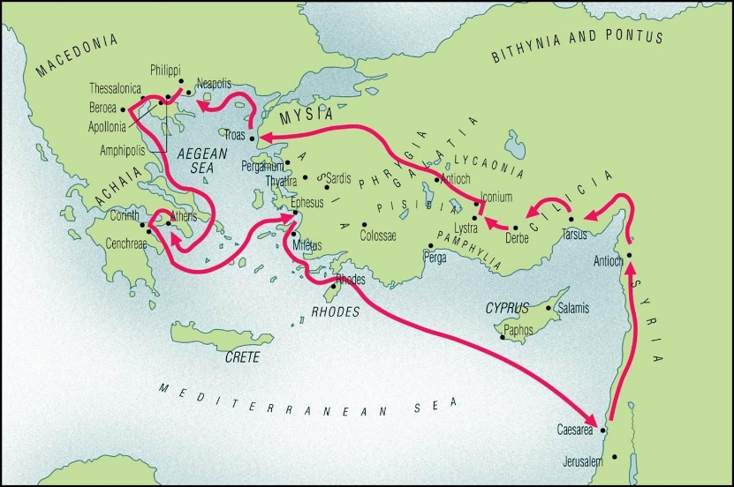
Paul’s Second Missionary Journey
Acts 15:36-18:22
3 years: 51 AD - 54 AD
Distance- 1290 miles by sea and 1410 miles by land – approx. 2700 miles.

- How and where does Paul begin his teaching in Thessalonica? What was he teaching? See Acts 17:1-4.

Acts 17:1-4 ¹ When they took the road through Amphipolis and Apollonia, they reached Thessalonica, where there was a synagogue of the Jews. ² Following his usual custom, Paul joined them, and for three sabbaths he entered into discussions with them from the scriptures, ³ expounding and demonstrating that the Messiah had to suffer and rise from the dead, and that “This is the Messiah, Jesus, whom I proclaim to you.” ⁴ Some of them were convinced and joined Paul and Silas; so, too, a great number of Greeks who were worshipers, and not a few of the prominent women.

- In verses 1-4 above, what evidence is there that Paul’s message was successful?
- What are the accusations against Jason, Paul and Silas? Why are these accusations unjust? See Acts 17:5-8.

Acts 17:5-8 ⁵ But the Jews became jealous and recruited some worthless men loitering in the public square, formed a mob, and set the city in turmoil. They marched on the house of Jason, intending to bring them before the people’s assembly. ⁶ When they could not find them, they dragged Jason and some of the brothers before the city magistrates, shouting, “These people who have been creating a disturbance all over the world have now come here, ⁷ and Jason has welcomed them. They all act in opposition to the decrees of Caesar and claim instead that there is another king, Jesus.”^{[b]} ⁸ They stirred up the crowd and the city magistrates who, upon hearing these charges, ⁹ took a surety payment from Jason and the others before releasing them.

- Read verse 7 again. How can this be considered a misunderstanding of Christian teaching? See Paul’s teachings in Romans 13:1-2 and Jesus’ teaching in Mark 12:14-17

Acts 17:7b They all act in opposition to the decrees of Caesar and claim instead that there is another king, Jesus.
Romans 13:1-2 ¹ Let every person be subordinate to the higher authorities, for there is no authority except from God, and those that exist have been established by God. ² Therefore, whoever resists authority opposes what God has appointed, and those who oppose it will bring judgment upon themselves.
Mark 12:14-17 ¹⁴ They came and said to him, “Teacher, we know that you are a truthful man and that you are not concerned with anyone’s opinion. You do not regard a person’s status but teach the way of God in accordance with the truth. Is it lawful to pay the census tax to Caesar or not? Should we pay or should we not pay?” ¹⁵ Knowing their hypocrisy he said to them, “Why are you testing me? Bring me a denarius to look at.” ¹⁶ They brought one to him and he said to them, “Whose image and inscription is this?” They replied to him, “Caesar’s.” ¹⁷ So Jesus said to them, “Repay to Caesar what belongs to Caesar and to God what belongs to God.”

- What is done to try and protect Paul from the angry Jews? See Acts 17:10-14.
Acts 17:10-14¹⁰ The brothers immediately sent Paul and Silas to Beroea during the night. Upon arrival they went to the synagogue of the Jews. ¹¹ These Jews were more fair-minded than those in Thessalonica, for they received the word with all willingness and examined the scriptures daily to determine whether these things were so. ¹² Many of them became believers, as did not a few of the influential Greek women and men. ¹³ But when the Jews of Thessalonica learned that the word of God had now been proclaimed by Paul in Beroea also, they came there too to cause a commotion and stir up the crowds. ¹⁴ So the brothers at once sent Paul on his way to the seacoast, while Silas and Timothy remained behind. ¹⁵ After Paul’s escorts had taken him to Athens, they came away with instructions for Silas and Timothy to join him as soon as possible. (note that it is 45 miles from Thessalonica to Beroea)

- Check footnotes for Acts 17:16-21. Who are the Epicureans and Stoic philosophers? What is their interest in Paul’s teaching?
Acts 17:16-21¹⁶ While Paul was waiting for them in Athens, he grew exasperated at the sight of the city full of idols. ¹⁷ So he debated in the synagogue with the Jews and with the worshipers, and daily in the public square with whoever happened to be there. ¹⁸ Even some of the Epicurean and Stoic philosophers^{[d]} engaged him in discussion. Some asked, “What is this scavenger trying to say?” Others said, “He sounds like a promoter of foreign deities,” because he was preaching about ‘Jesus’ and ‘Resurrection.’ ¹⁹ They took him and led him to the Areopagus^{[e]} and said, “May we learn what this new teaching is that you speak of? ²⁰ For you bring some strange notions to our ears; we should like to know what these things mean.” ²¹ Now all the Athenians as well as the foreigners residing there used their time for nothing else but telling or hearing something new.

- What is the significance of the altars to “the unknown god”? How does Paul use this to appeal to the Athenian philosophers? See Acts 17:22-31 and footnotes.
Acts 17:22-31 “You Athenians, I see that in every respect you are very religious. ²³ For as I walked around looking carefully at your shrines, I even discovered an altar inscribed, ‘To an Unknown God.’^{[g]} What therefore you unknowingly worship, I proclaim to you. ²⁴ The God who made the world and all that is in it, the Lord of heaven and earth, does not dwell in sanctuaries made by human hands, ²⁵ nor is he served by human hands because he needs anything. Rather it is he who gives to everyone life and breath and everything. ²⁶ He made from one the whole human race to dwell on the entire surface of the earth, and he fixed the ordered seasons and the boundaries of their regions, ²⁷ so that people might seek God, even perhaps grope for him and find him, though indeed he is not far from any one of us. ²⁸ For ‘In him we live and move and have our being,’ as even some of your poets have said, ‘For we too are his offspring.’ ²⁹ Since therefore we are the offspring of God, we ought not to think that the divinity is like an image fashioned from gold, silver, or stone by human art and imagination. ³⁰ God has overlooked the times of ignorance, but now he demands that all people everywhere repent ³¹ because he has established a day on which he will ‘judge the world with justice’ through a man he has appointed, and he has provided confirmation for all by raising him from the dead.”
- How does Paul describe God to the people of Athens at the Areopagus?
Read again Acts 17:22-31 above.

- What part of Paul’s teaching is most intriguing or confusing for the Athenians? Check footnotes and Acts 17:30-34.
Acts 17:30-34.³⁰ God has overlooked the times of ignorance, but now he demands that all people everywhere repent ³¹ because he has established a day on which he will ‘judge the world with justice’ through a man he has appointed, and he has provided confirmation for all by raising him from the dead.” ³² When they heard about resurrection of the dead, some began to scoff, but others said, “We should like to hear you on this some other time.” ³³ And so Paul left them. ³⁴ But some did join him, and became believers. Among them were Dionysius, a member of the Court of the Areopagus, a woman named Damaris, and others with them.

