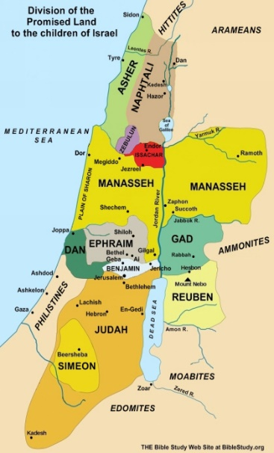
Hosea 5
Guilt of the Religious & Political Leaders
Lesson 20

- Reflect on the past week. When did you feel closest to God? OR, was there a particular verse or message from this week’s lesson on Hosea that you found inspiring in some way?

- Check for footnotes on the places mentioned in verses 1 and 2, Mizpah, Tabor, and Shittim. What is the significance of these places?

- Bring your Bible to this class. Compare translations of verses 1 and 2 with others in your group. There may be differences even between the NAB and NABRE. Do the differences in translation make a significant difference in meaning?

- Read verses 3-4. Why would it be impossible for Ephraim and Israel to return to God?
Hosea 5:3-4
I know Ephraim,
and Israel is not hidden from me:
Now, Ephraim, you have practiced prostitution,
Israel is defiled.
⁴ Their deeds do not allow them
to return to their God;
For the spirit of prostitution is in them,
and they do not know the Lord.

- Reflect on how our actions or lack of actions become bad habits in our lives in general.
How difficult is it to change habitual behavior that has lasted a lifetime?
When it comes to our spiritual life, what are the consequences of bad habits or spiritual neglect?

- Read verses 5-7. Look for footnotes for clues to the meaning of the terms “new moon” and “illegitimate children”. How do these terms suggest pagan practices that have isolated the Israelites from YHWH?
Hosea 5:5-7 (NABRE)
The arrogance of Israel bears witness against him;
Israel and Ephraim stumble because of their iniquity, and Judah stumbles with them.
⁶ With their flocks and herds they will go to seek the Lord, but will not find him;
he has withdrawn from them.
⁷ They have betrayed the Lord, for they have borne illegitimate children;
Now the new moon will devour them together with their fields.

- The sins that have so angered God are explained in 2 Kings 15:13-20. What are the offences noted there?
2Kings 15:13-20 ¹³ Shallum, son of Jabesh, became king in the thirty-ninth year of Uzziah, king of Judah; he reigned one month in Samaria. ¹⁴ Menahem, son of Gadi, came up from Tirzah to Samaria, and struck down Shallum, son of Jabesh, in Samaria. He killed him and reigned in his place.
¹⁵ As for the rest of the acts of Shallum, with the conspiracy he carried out, these are recorded in the book of the chronicles of the kings of Israel. ¹⁶ At that time, Menahem attacked Tappuah, all its inhabitants, and its whole district as far as Tirzah, because they did not let him in. He attacked them; he even ripped open all their pregnant women.
Reign of Menahem of Israel. ¹⁷ In the thirty-ninth year of Azariah, king of Judah, Menahem, son of Gadi, became king over Israel for ten years in Samaria. ¹⁸ He did what was evil in the Lord’s sight as long as he lived, not desisting from the sins that Jeroboam, son of Nebat, had caused Israel to commit. ¹⁹ Pul,^{[c]} king of Assyria, came against the land. But Menahem gave Pul a thousand talents of silver to have his help in holding onto his kingdom. ²⁰ Menahem paid out silver on behalf of Israel, that is, for all the people of substance, by giving the king of Assyria fifty shekels of silver for each one. So the king of Assyria went home and did not stay in the land.

- How long will God’s wrath and punishment last for Ephraim, Benjamin and Judah? See versed 13-15.

Hosea 5:13-15. For I am like a lion to Ephraim, like a young lion to the house of Judah; It is I who tear the prey and depart, I carry it away and no one can save it. ¹⁵ I will go back to my place until they make reparation and seek my presence. In their affliction, they shall look for me.

- Reflection. What do these verses tell us about the justice of God? How does it confirm our beliefs in the necessity of repentance?

