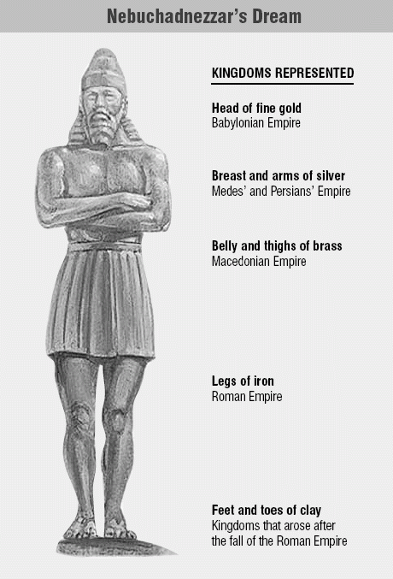
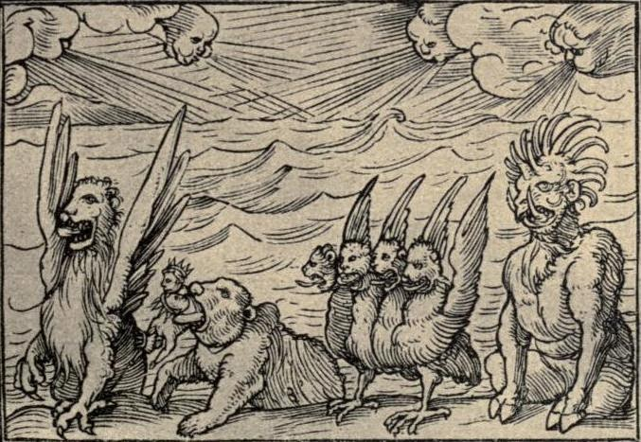
Daniel 7
Beasts and Judgment
Lesson 9

- Reflecting on your experiences this past week, was there a moment when you felt closest to God? OR, was there a particular verse or lesson in our lesson on Daniel 7 that your found inspirational?

- In Genesis’ creation story, the spirit of God hovers over the waters and creation begins. All that God created was good. Here in this vision, the sea represents chaos. What is emerging from the seas of chaos and disorder here? See Daniel 7:2-8.
Daniel 7:2-8² In the vision I saw during the night, suddenly the four winds of heaven stirred up the great sea, ³ from which emerged four immense beasts, each different from the others. ⁴ The first was like a lion, but with eagle’s wings. While I watched, the wings were plucked; it was raised from the ground to stand on two feet like a human being, and given a human mind. ⁵ The second beast was like a bear; it was raised up on one side, and among the teeth in its mouth were three tusks. It was given the order, “Arise, devour much flesh.” ⁶ After this I looked and saw another beast, like a leopard; on its back were four wings like those of a bird, and it had four heads. To this beast dominion was given. ⁷ After this, in the visions of the night I saw a fourth beast, terrifying, horrible, and of extraordinary strength; it had great iron teeth with which it devoured and crushed, and it trampled with its feet what was left. It differed from the beasts that preceded it. It had ten horns. ⁸ I was considering the ten horns it had, when suddenly another, a little horn, sprang out of their midst, and three of the previous horns were torn away to make room for it. This horn had eyes like human eyes, and a mouth that spoke arrogantly.

- Read the footnotes in your Bible if you have them. What do the four beasts represent?
Winged lion
Beast like a bear with three tusks
Beast like a leopard with four wings and four heads
Beast with iron teeth and ten horns

- In Nebuchadnezzar’s Dream in chapter 2, we saw another prophecy/vision of kingdoms past, present and future. How are these images or the meaning of the visions similar? How are they different? Compare Daniel 2:31-45 with Daniel 7:2-8 (above)
Daniel 2:31-45 “Your Majesty looked, and there before you stood a large statue—an enormous, dazzling statue, awesome in appearance. ³² The head of the statue was made of pure gold, its chest and arms of silver, its belly and thighs of bronze, ³³ its legs of iron, its feet partly of iron and partly of baked clay. ³⁴ While you were watching, a rock was cut out, but not by human hands. It struck the statue on its feet of iron and clay and smashed them. ³⁵ Then the iron, the clay, the bronze, the silver and the gold were all broken to pieces and became like chaff on a threshing floor in the summer. The wind swept them away without leaving a trace. But the rock that struck the statue became a huge mountain and filled the whole earth.
³⁶ “This was the dream, and now we will interpret it to the king. ³⁷ Your Majesty, you are the king of kings. The God of heaven has given you dominion and power and might and glory; ³⁸ in your hands he has placed all mankind and the beasts of the field and the birds in the sky. Wherever they live, he has made you ruler over them all. You are that head of gold.
³⁹ “After you, another kingdom will arise, inferior to yours. Next, a third kingdom, one of bronze, will rule over the whole earth. ⁴⁰ Finally, there will be a fourth kingdom, strong as iron—for iron breaks and smashes everything—and as iron breaks things to pieces, so it will crush and break all the others. ⁴¹ Just as you saw that the feet and toes were partly of baked clay and partly of iron, so this will be a divided kingdom; yet it will have some of the strength of iron in it, even as you saw iron mixed with clay. ⁴² As the toes were partly iron and partly clay, so this kingdom will be partly strong and partly brittle. ⁴³ And just as you saw the iron mixed with baked clay, so the people will be a mixture and will not remain united, any more than iron mixes with clay.
⁴⁴ “In the time of those kings, the God of heaven will set up a kingdom that will never be destroyed, nor will it be left to another people. It will crush all those kingdoms and bring them to an end, but it will itself endure forever. ⁴⁵ This is the meaning of the vision of the rock cut out of a mountain, but not by human hands—a rock that broke the iron, the bronze, the clay, the silver and the gold to pieces.

- In the poetic verses of Daniel 7:9-11, who is the “Ancient of Days”?
As I watched,
Thrones were set up
and the Ancient of Days took his throne.
His clothing was white as snow,
the hair on his head like pure wool;
His throne was flames of fire,
with wheels of burning fire.
¹⁰ A river of fire surged forth,
flowing from where he sat;
Thousands upon thousands were ministering to him,
and myriads upon myriads stood before him.
The court was convened, and the books were opened.

- Ultimately, what is the fate of the various kingdoms of the earth according to Daniel’s vision? What was the fate of nations in Nebuchadnezzar’s vision? See Daniel 7:11-12 and Daniel 2:44 (above).

Daniel 7:11-12 ¹ I watched, then, from the first of the arrogant words which the horn spoke, until the beast was slain and its body destroyed and thrown into the burning fire. ¹² As for the other beasts, their dominion was taken away, but they were granted a prolongation of life for a time and a season.

- What powers will be given to “One like a Son of Man” in Daniel 7:13-14? To whom are these verses referring?
Daniel 7:13-14
As the visions during the night continued, I saw coming with the clouds of heaven
One like a son of man.
When he reached the Ancient of Days
and was presented before him,
¹⁴ He received dominion, splendor, and kingship;
all nations, peoples and tongues will serve him.
His dominion is an everlasting dominion
that shall not pass away,
his kingship, one that shall not be destroyed.

- The interpretation of Daniel’s vision presents a prophecy of a fourth evil nation or beast that will reign for a period of time. Persecutions will continue, God will be cursed and this evil power will attempt to interfere with practices of faith and the Holy Law. What will ultimately happen to this fourth beast?
See Daniel 7:23-27.

Daniel 7:23-27
The fourth beast shall be a fourth kingdom on earth,
different from all the others;
The whole earth it shall devour,
trample down and crush.
²⁴ The ten horns shall be ten kings
rising out of that kingdom;
another shall rise up after them,
Different from those before him,
who shall lay low three kings.
²⁵ He shall speak against the Most High
and wear down the holy ones of the Most High,
intending to change the feast days and the law.^{[j]}
They shall be handed over to him
for a time, two times, and half a time.
²⁶ But when the court is convened,
and his dominion is taken away
to be abolished and completely destroyed,
²⁷ Then the kingship and dominion and majesty
of all the kingdoms under the heavens
shall be given to the people of the holy ones of the Most High,
Whose kingship shall be an everlasting kingship,
whom all dominions shall serve and obey.”

- The interpretation of Daniel’s vision explains the fate of those who are holy and faithful. What is to be their ultimate fate? See Daniel 7:23-27 above.

- For those who have been persecuted and oppressed for being faithful to God, how is the message of Daniel 7 comforting?

