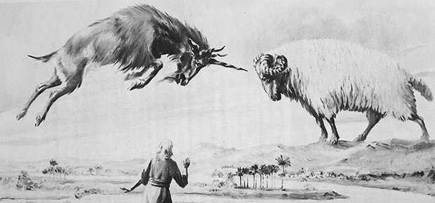
Daniel 8
Visions of the Ram and He-Goat
Lesson 10

Last week we saw Daniel’s dreams/visions of terrifying beasts. It is a prophesy of end times and includes the demise of evil forces on earth and the salvation of the faithful. Ultimately the Kingdom of God will emerge, with the Son of Man, Jesus, reigning as Judge and King. This week Daniel has new visions.
- When in this past week did you feel particularly close to God? OR was there a particular verse or message in this week’s study of Daniel that you found inspiring?

- If your Bible has footnotes, what does it say about the who the sheep and the goat represent?
Sheep with two horns-
Goat from the west with one horn-

- Again, check your footnotes to see who the “little horn” in 8:9 is referring to. See Daniel 8:8-11.

Daniel 8:8-11 The he-goat grew very powerful, but at the height of its strength the great horn was shattered, and in its place came up four others, facing the four winds of heaven. ⁹ Out of one of them came a little horn which grew and grew toward the south, the east, and the glorious land. ¹⁰ It grew even to the host of heaven, so that it cast down to earth some of the host and some of the stars and trampled on them. ¹¹ It grew even to the Prince of the host, from whom the daily sacrifice was removed, and whose sanctuary was cast down. ¹² The host was given over together with the daily sacrifice in the course of transgression. It cast truth to the ground, and was succeeding in its undertaking.

- Isaiah 14 also depicts this same ruler. Read Isaiah 14:12-14. What seems to be the fatal character flaw that causes the downfall of this leader?
Isaiah 14:12-14
“How you have fallen from heaven,
O ^{[g]}star of the morning, son of the dawn!
You have been cut down to the earth,
You who have weakened the nations!
¹³ “But you said in your heart,
‘I will ascend to heaven;
I will raise my throne above the stars of God,
And I will sit on the mount of assembly
In the recesses of the north.
¹⁴ ‘I will ascend above the heights of the clouds;
I will make myself like the Most High.’

- 1 Maccabees 1:41-61 records the actions of Antiochus Epiphanes in the Temple in Jerusalem. They are also referred to in Daniel 8:11-12. What are some of the atrocities against the Jewish people that Antiochus is responsible for? See 1 Macc 1:41-61 and Daniel 8:11-12 above.
1 Macc 1:41-61 Then the king wrote to his whole kingdom that all should be one people,42 and abandon their particular customs. All the Gentiles conformed to the command of the king,43and many Israelites delighted in his religion; they sacrificed to idols and profaned the sabbath.
44The king sent letters by messenger to Jerusalem and to the cities of Judah, ordering them to follow customs foreign to their land; 45 to prohibit burnt offerings, sacrifices, and libations in the sanctuary, to profane the sabbaths and feast days, 46 to desecrate the sanctuary and the sacred ministers,47 to build pagan altars and temples and shrines, to sacrifice swine and unclean animals,48 to leave their sons uncircumcised, and to defile themselves with every kind of impurity and abomination;49so that they might forget the law and change all its ordinances.50 Whoever refused to act according to the command of the king was to be put to death.
51 In words such as these he wrote to his whole kingdom. He appointed inspectors over all the people, and he ordered the cities of Judah to offer sacrifices, each city in turn. 52 Many of the people, those who abandoned the law, joined them and committed evil in the land. 53 They drove Israel into hiding, wherever places of refuge could be found.
54 On the fifteenth day of the month Kislev, in the year one hundred and forty-five, the king erected the desolating abomination upon the altar of burnt offerings, and in the surrounding cities of Judah they built pagan altars. 55 They also burned incense at the doors of houses and in the streets. 56 Any scrolls of the law that they found they tore up and burned. 57 Whoever was found with a scroll of the covenant, and whoever observed the law, was condemned to death by royal decree. 58 So they used their power against Israel, against those who were caught, each month, in the cities. 59 On the twenty-fifth day of each month they sacrificed on the pagan altar that was over the altar of burnt offerings. 60 In keeping with the decree, they put to death women who had their children circumcised, 61and they hung their babies from their necks; their families also and those who had circumcised them were killed.

- This time, Daniel’s visions are interpreted by the angel Gabriel. How does Gabriel explain the meaning of the horns and the ram? See Dan 8:20-22.

Dan 8:20-22 “The two-horned ram you saw represents the kings of the Medes and Persians.^{[h]} ²¹ The he-goat is the king of the Greeks, and the great horn on its forehead is the first king. ²² The four that rose in its place when it was shattered are four kingdoms that will issue from his nation, but without his strength.

- Who ultimately will bring the terrible reign of Antiochus to an end according to Gabriel? See Daniel 8:23-25.
Daniel 8:23-25.
“At the end of their reign,
when sinners have reached their measure,
There shall arise a king,
impudent, and skilled in intrigue.
²⁴ He shall be strong and powerful,
bring about fearful ruin,
and succeed in his undertaking.
He shall destroy powerful peoples;
²⁵ his cunning shall be against the holy ones,
his treacherous conduct shall succeed.
He shall be proud of heart
and destroy many by stealth.
But when he rises against the Prince of princes,
he shall be broken without a hand being raised.

- Reflect. Who is really in control of world events? If you were persecuted for your faith to the extent that these Jews were, would the message of Daniel 7 and 8 be comforting or terrifying?

